**4D Motion Vest and Sensors (Wearable sensors)**

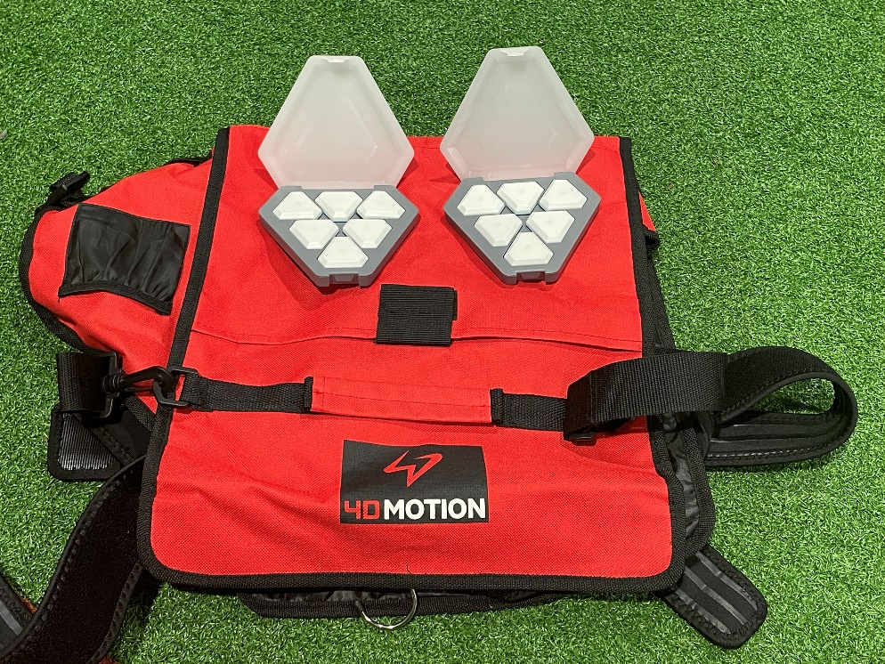

**ProplayAi Example Data---Replace data for Catapult or 4D**

**PitchLogic**

**Armcare Dynamometer**

